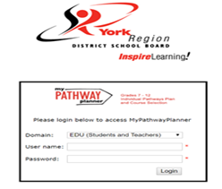
This step-by-step guide will help you complete your Not Returning form using the myBlueprint website.

- Visit www.myblueprint.ca
- Click Log In at the top right
- Enter your email and password, click Login

Not returning next year?

- From your Dashboard, click on High school, and then on Not returning next year? The button that appears in the High School Progress box.

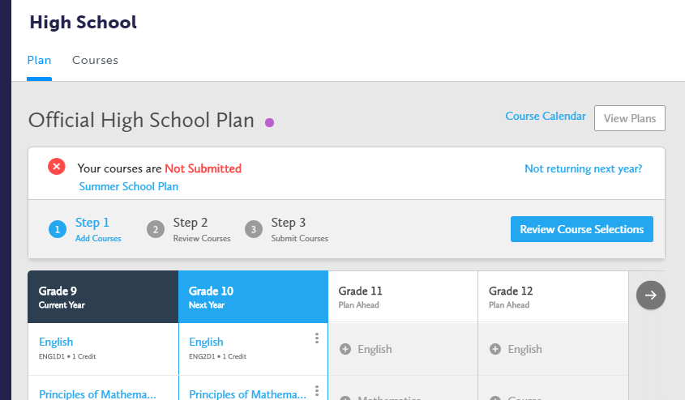

- Select the option that suits your pathway and press confirm.
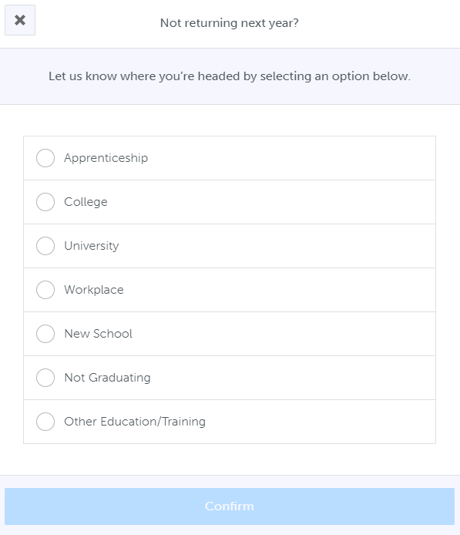

You’re Done!
Please submit your electronic Not Returning Form by Friday, February 25, 2022.

