



Redstone P.S. is accepting online payments through School Cash ONLINE!

School Cash Online provides the following benefits:
• A convenient fee payment option that saves time
• Reduces paper
• No more need to send cash or cheques to school
• A quick way to register. It takes less than 5 minutes to register.

Parents that opt to participate will receive notification via email of student fees owed (both required and optional), and can make secure online payments by credit card or Interac and receive a receipt.

To view a presentation about the program, go to http://www.kevsoftware.com/movies/ParentRegEnglish/.

Follow the easy steps on the next page to register and get started!

Step 1: Register

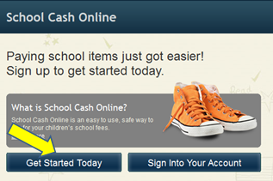
- Click on the School Cash Online button on our school’s website at http://redstone.ps.yrdsb.ca/
and select the “Get Started Today” button.

- Complete each of the three Registration Steps

*For Security Reasons your password, requires 8 characters,
one uppercase letter, one lowercase letter and a number.

Step 2: Confirmation Email
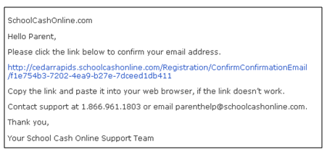
A registration confirmation email will be automatically forwarded to you. Click on the link provided inside the email to confirm your email and School Cash Online account. The confirmation link will open the School Cash Online site prompting you to sign into your account. Use your email address and password just created with your account.
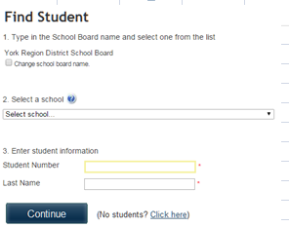
Step 3: Find Student
NOTE: A STUDENT NUMBER IS REQUIRED
This step will connect your children to your account.

- Enter the School Board Name
- Enter the School Name
- Enter Your Child’s Student # and Last Name
- Select Continue
- On the next page confirm that you are related to the child, check in the Agree box and select Continue
- Your child has been added to your account

Step 4: View Items or Add Another Student

If you have more children, select “Add Another Student” option and repeat the steps above. 5 children can be added to one parent account.
If you do not wish to add additional children, select “View Items For Students” option. A listing of available items for purchase will be displayed.

NEED HELP?
If you require assistance, select the GET HELP option in the top right hand corner of the screen or contact School Cash Online – Parent Help Desk at 1-866-961-1803 or parenthelp@schoolcashonline.com.

