Course: Introduction to Computer Science – Grade 11
Code: ICS3U
Teacher: Mrs. Grigorova, classroom 305, office room 315

Equipment Required: Binder, USB memory stick

Course Objectives
This course introduces students to computer programming. Students will design software independently and as part of a team, using industry-standard programming tools and applying the software development life-cycle model. They will also write and use subprograms within computer programs. Students will develop creative solutions for various types of problems as their understanding of the computing environment grows. They will also explore environmental and ergonomic issues, emerging research in computer science, and global career trends in computer-related fields.

Prerequisite: None
Course Topics | Introductory Programming Concepts & Skills | Advanced Programming  Concepts & Skills | Software Development | Final  Project
Number of Classes | 20 | 20 | 30 | 15
Note: The number of class periods is intended as a rough estimate.
Evaluation | Term Work |  |  |  | Final Assessments
 | Knowledge and Understanding | Application | Thinking | Communication | Final Project | Final  Exam
Weighting | 10 | 25 | 25 | 10 | 15 | 15

Course Moodle Website Address: http://moodle2.yrdsb.ca/
Course: ICS3U@Westmount
Enrolment Key: programmer
Participation and Attitude
Attendance is crucial to ensure success in this course. Absences must be explained through the attendance office. Numerous absences will be referred to a vice-principal.
Inform me ahead of time if you know you will be absent for a class or classes especially for tests.
Arrive on time for each class.
Make an effort to keep up with the work and do well.
Ask questions! Don’t be afraid to take a risk.
Help others – both in your group and with individual problems.

Academic Achievement
Extra help will be available after school on most days. Please come for extra help as soon as you realize you need it - that way, little problems won't become big ones.
It is important that submitted assignments reflect the student’s ability. Plagiarism is not tolerated. Please see the student agenda regarding consequences for plagiarism and how to avoid it.

Respect for the learning environment:
- No food or drink in the classroom except bottled water.
- No game playing, messaging, emailing, or internet surfing unrelated to work assigned in the course.
- Do not share your files with anyone.
- Do not touch anyone else’s computer, even if you are helping them. Help by explaining not by doing.
- Do not move any computer or components from its original location without the teacher’s permission.
- Cell phones, Smart phones, PDAs, iPods, Tablets, and other technological devices must be turned off in class and put away so that the learning environment is not interrupted. These devices may be confiscated if used inappropriately. Please refer to the student agenda book for more detailed information about policies and procedures regarding technology.

Learning Skills & Work Habits | Sample Behaviours  * The highlighted learning Skills & Work Habits are especially important in programming
Responsibility | The student:  • fulfils responsibilities and commitments within the learning environment;  • completes and submits class work, homework, and assignments according to agreed-upon timelines;  • takes responsibility for and manages own behaviour.
Organization | The student:  • devises and follows a plan and process for completing work and tasks;  • establishes priorities and manages time to complete tasks and achieve goals;  • identifies, gathers, evaluates, and uses information, technology, and resources to complete tasks.
Independent Work | The student:  • independently monitors, assesses, and revises plans to complete tasks and meet goals;  • uses class time appropriately to complete tasks;  • follows instructions with minimal supervision.
Collaboration | The student:  • accepts various roles and an equitable share of work in a group;  • responds positively to the ideas, opinions, values, and traditions of others;  • builds healthy peer-to-peer relationships through personal and media-assisted interactions;  • works with others to resolve conflicts and build consensus to achieve group goals;  • shares resources and expertise and promotes critical thinking to solve problems and make decisions.
Initiative | The student:  • looks for and acts on new ideas and opportunities for learning;  • demonstrates the capacity for innovation and a willingness to take risks;  • demonstrates curiosity and interest in learning;  • approaches new tasks with a positive attitude;  • recognizes and advocates appropriately for the rights of self and others.
Self-regulation | The student:  • sets own individual goals and monitors progress towards achieving them;  • seeks clarification or assistance when needed;  • assesses and reflects critically on own strengths, needs, and interests;  • identifies learning opportunities, choices, and strategies to meet personal needs and achieve goals;  • perseveres and makes an effort when responding to challenges.

If you have concerns about your progress in the course, you should discuss them with me right away.
Thank you for choosing this course! Mrs. Grigorova
Student Signature: _____________________________ Date:_____________________

Parent Signature: ______________________________ Date:_____________________

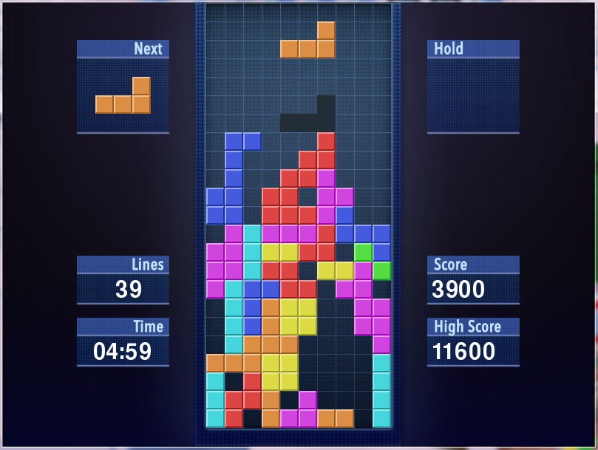
Concepts & Games Completed in Class
-- Hangman(Strings)
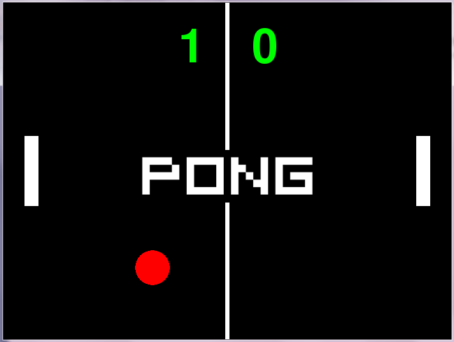
-- Pong (Intro to Pygame)
-- Pop the Balloons(Lists)
-- Tetris

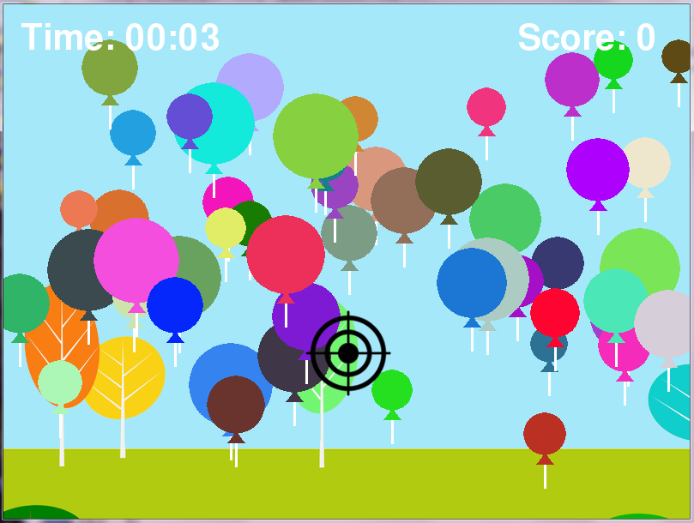

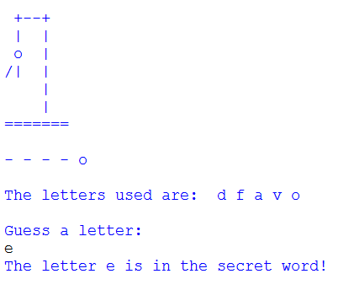

Game
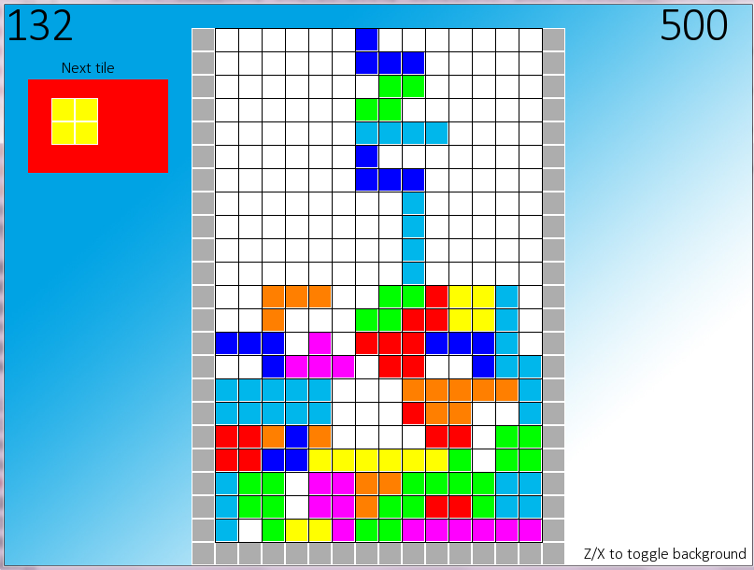
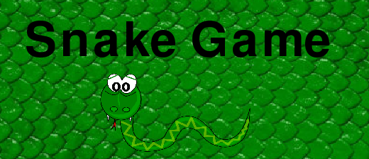
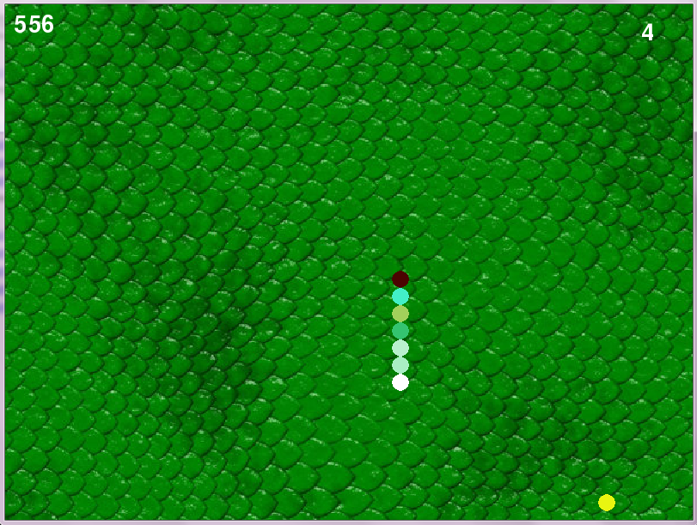
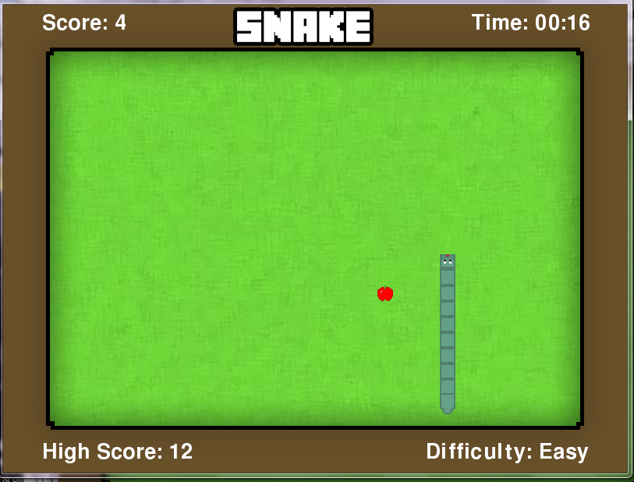
-- Snake(Lists & Functions)
--Tetris(OOP)
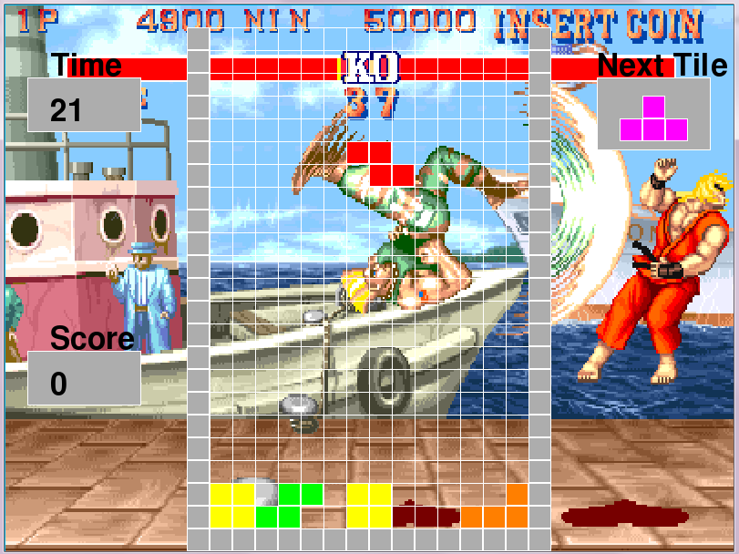

Final Project (A Game of Your Choice)
